CHECK Constraint

🌟 Definition
# Source: AI Source: Provided by: [Data Path: Persons Table -> ID Column: 1, Name_En Column: Motasem Essam] -> From: [ChatGPT] on [6/10/2026]
A CHECK Constraint is a rule that ensures values stored in a column satisfy a specified condition.
If the condition evaluates to TRUE, the data is accepted.
If the condition evaluates to FALSE, the database rejects the data.

🎯 Purpose
# Source: AI Source: Provided by: [Data Path: Persons Table -> ID Column: 1, Name_En Column: Motasem Essam] -> From: [ChatGPT] on [6/10/2026]
The CHECK constraint is used to:
- Validate data before storage
- Enforce business rules
- Prevent invalid values
- Improve data integrity

🧠 Simple Example
# Source: AI Source: Provided by: [Data Path: Persons Table -> ID Column: 1, Name_En Column: Motasem Essam] -> From: [ChatGPT] on [6/10/2026]
Suppose a company only hires adults.
Rule:
Age must be 18 or greater.
Valid:
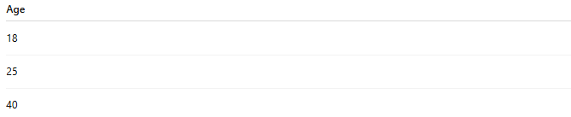
Age
18
25
40

Invalid:
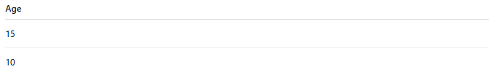
Age
15
10
These values violate the rule.

📚 Real-World Examples
# Source: AI Source: Provided by: [Data Path: Persons Table -> ID Column: 1, Name_En Column: Motasem Essam] -> From: [ChatGPT] on [6/10/2026]
1. Age Validation
Age >= 18

2. Exam Score Validation
Score BETWEEN 0 AND 100

3. Product Price Validation
Price > 0

4. Employee Salary Validation
Salary >= 0

5. Quantity Validation
Quantity >= 1

🗄️ SQL Example
# Source: AI Source: Provided by: [Data Path: Persons Table -> ID Column: 1, Name_En Column: Motasem Essam] -> From: [ChatGPT] on [6/10/2026]
Age Check
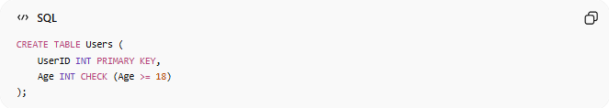
CREATE TABLE Users (
UserID INT PRIMARY KEY,
Age INT CHECK (Age >= 18)
);

Valid Insert
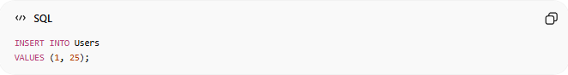
INSERT INTO Users
VALUES (1, 25);
Result:
Success

Invalid Insert
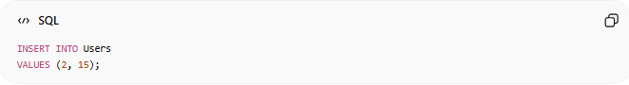
INSERT INTO Users
VALUES (2, 15);
Result:
Error
Because:
15 >= 18
is false.

📊 Database Example
# Source: AI Source: Provided by: [Data Path: Persons Table -> ID Column: 1, Name_En Column: Motasem Essam] -> From: [ChatGPT] on [6/10/2026]
Products Table
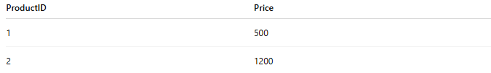
ProductID | Price
1 | 500
2 | 1200
Rule:
Price > 0

Valid:
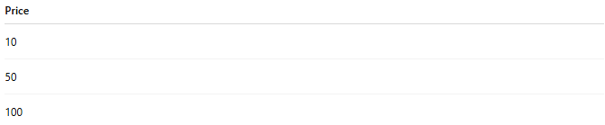
Price
10
50
100

Invalid:
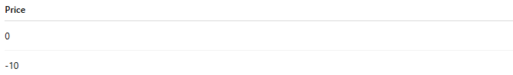
Price
0
-10
Negative prices are rejected.

🔢 Characteristics of CHECK Constraints
# Source: AI Source: Provided by: [Data Path: Persons Table -> ID Column: 1, Name_En Column: Motasem Essam] -> From: [ChatGPT] on [6/10/2026]
A CHECK constraint:
- Evaluates a condition
- Accepts valid data
- Rejects invalid data
- Can use comparison operators
- Can enforce business logic

📚 Common Operators Used in CHECK
# Source: AI Source: Provided by: [Data Path: Persons Table -> ID Column: 1, Name_En Column: Motasem Essam] -> From: [ChatGPT] on [6/10/2026]
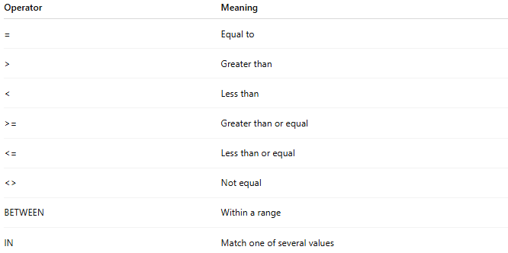
Operator | Meaning
= | Equal to
> | Greater than
< | Less than
>= | Greater than or equal
<= | Less than or equal
<> | Not equal
BETWEEN | Within a range
IN | Match one of several values

🗄️ Example: Range Validation
Score Table
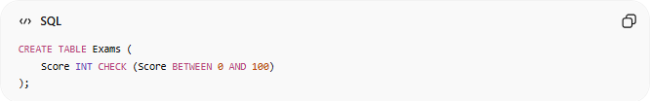
CREATE TABLE Exams (
Score INT CHECK (Score BETWEEN 0 AND 100)
);

Valid:
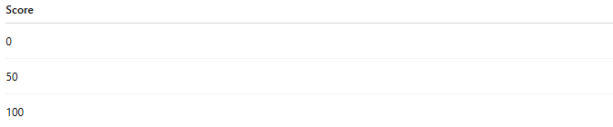
Score
0
50
100

Invalid:
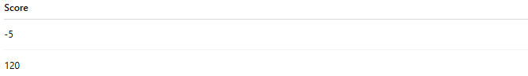
Score
-5
120

🗄️ Example: Limited Values
# Source: AI Source: Provided by: [Data Path: Persons Table -> ID Column: 1, Name_En Column: Motasem Essam] -> From: [ChatGPT] on [6/10/2026]
Gender Column
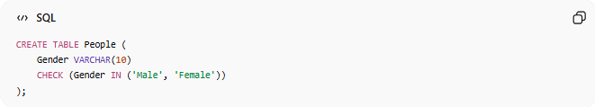
CREATE TABLE People (
Gender VARCHAR(10)
CHECK (Gender IN ('Male', 'Female'))
);

Valid:
Male
Female

Invalid:
Unknown
ABC

🗄️ Example: Positive Salary
# Source: AI Source: Provided by: [Data Path: Persons Table -> ID Column: 1, Name_En Column: Motasem Essam] -> From: [ChatGPT] on [6/10/2026]
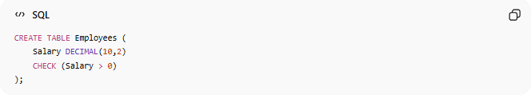
CREATE TABLE Employees (
Salary DECIMAL(10,2)
CHECK (Salary > 0)
);

Valid:
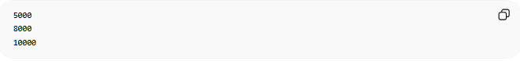
5000
8000
10000

Invalid:
0
-500

🌍 Online Store Example
# Source: AI Source: Provided by: [Data Path: Persons Table -> ID Column: 1, Name_En Column: Motasem Essam] -> From: [ChatGPT] on [6/10/2026]
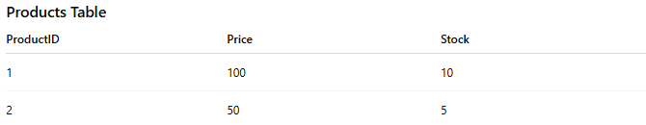
Products Table
ProductID | Price | Stock
1 | 100 | 10
2 | 50 | 5
Rules:
Price > 0
Stock >= 0
SQL:
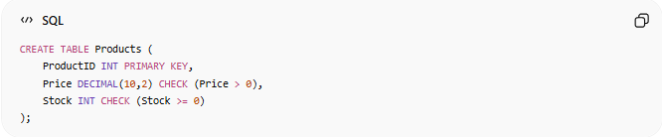
CREATE TABLE Products (
ProductID INT PRIMARY KEY,
Price DECIMAL(10,2) CHECK (Price > 0),
Stock INT CHECK (Stock >= 0)
);

⚠️ CHECK vs NOT NULL
# Source: AI Source: Provided by: [Data Path: Persons Table -> ID Column: 1, Name_En Column: Motasem Essam] -> From: [ChatGPT] on [6/10/2026]
NOT NULL
Requires a value.
Example:
Age cannot be NULL.

CHECK
Validates the value.
Example:
Age must be >= 18.

Comparison
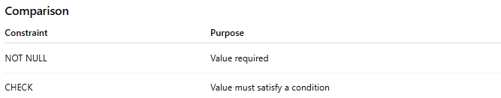
Constraint | Purpose
NOT NULL | Value required
CHECK | Value must satisfy a condition

⚠️ CHECK vs UNIQUE
# Source: AI Source: Provided by: [Data Path: Persons Table -> ID Column: 1, Name_En Column: Motasem Essam] -> From: [ChatGPT] on [6/10/2026]
UNIQUE
No duplicates allowed.

CHECK
Values must meet a condition.

Example
Email → UNIQUE
Age → CHECK(Age >= 18)

📚 Common CHECK Rules
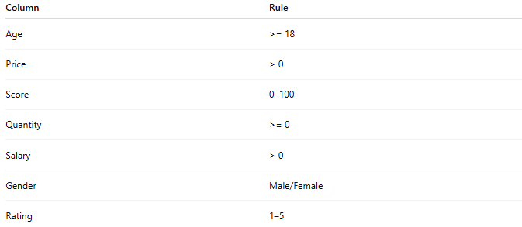
Column | Rule
Age | >= 18
Price | > 0
Score | 0–100
Quantity | >= 0
Salary | > 0
Gender | Male/Female
Rating | 1–5

🧠 Simple Analogy
# Source: AI Source: Provided by: [Data Path: Persons Table -> ID Column: 1, Name_En Column: Motasem Essam] -> From: [ChatGPT] on [6/10/2026]
Think of a university exam system.
Rule:
Exam scores must be between 0 and 100.
If a teacher enters:
150
the system rejects it.
The rule acts like a CHECK Constraint.

🧭 Summary
# Source: AI Source: Provided by: [Data Path: Persons Table -> ID Column: 1, Name_En Column: Motasem Essam] -> From: [ChatGPT] on [6/10/2026]
A CHECK Constraint is a rule that validates data by requiring values to satisfy a specified condition. It is commonly used to enforce business rules such as Age ≥ 18, Price > 0, Score between 0 and 100, and Quantity ≥ 0, helping maintain accurate and reliable data in a database.

